College of Fisheries
Sl No | Name | Designation | Department | College | Aadhar No. | Email Id | Mobile No. | Photo
 | Dr. Avdhesh Kumar | Prof. & Head, Dean | Aquaculture | College of  Fisheries | 939377640328 | profakfish@gmail.com | 9411160102  9417234129 | 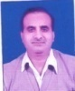
 | Dr. Vipul Gupta | Prof. & Head | FHPT | College of  Fisheries | 258567207700 | vipulgupta24@gmail.com | 7500241558 | 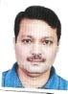
 | Dr. Ashutosh Mishra | Prof. & Head | AEM | College of  Fisheries | 345927066140 | ashutosh36in@yahoo.co.in | 9410120651 | 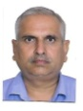
 | Dr. Rajesh | Professor | Aquaculture | College of  Fisheries | 753934156328 | rajeshfish100@gmail.com | 9412327100 | 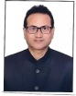
 | Dr. Anup Kumar | Professor | FHPT | College of  Fisheries | 618901344667 | anopsachan@gmail.com | 9411122943 | 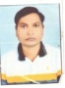
 | Dr. Akansha Khati | Asstt. Prof. | Aquaculture | College of  Fisheries | 686480463294 | akanshakhati@gmail.com | 8650602200 | 